1. Install Docker

sudo apt-get update
sudo apt install docker.io

2. Pull the image
sudo docker pull qiyeim/rtcserver:latest

3. Operation
sudo docker run -itd --restart=always -e "ACCEPT_EULA=Y" -e "SA_PASSWORD=Qiyeim.com" \
-p 1433:1433 -p 97:97 -p 98:98 -p 99:99 -p 5994:5994 -p 5995:5995 -p 5996:5996 -p 5997:5997 -p 5998:5998 \
-p 6001:6001 -p 6002:6002 -p 6003:6003 -p 6004:6004 -p 6005:6005 -p 6006:6006 -p 6007:6007 -p 6008:6008 --name rtcserver \
-d qiyeim/rtcserver:latest
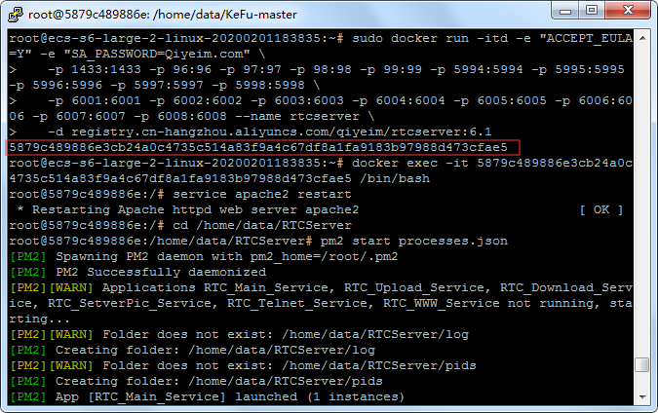
Returns the container ID and opens Docker
sudo docker exec-u 0-it containerID /bin/bash
Enter in the Docker terminal
sudo service apache2 restart
Open http://server IP:98 and configure the database (click Next directly without changing the database name or password).
cd /home/ubuntu/RTCServer
sudo pm2 start processes.json
/etc/init.d/redis-server start
cd /home/ubuntu/KeFu-master
sudo pm2 start bin/www --name kefu
- Set up the server
4.1 Automatically run the Docker script upon startup
sudo vi /etc/rc.local
Add before exit 0
sudo sleep 20
sudo docker start container ID
sudo sleep 20
sudo docker exec container ID /bin/sh /home/ubuntu/run.sh
If the system cannot locate rc.local, you can manually configure it. For more details, visit: https://blog.csdn.net/lk_luck/article/details/108361857
4.2 Set the server to restart automatically every day
sudo su
vim /etc/crontab
add
00 02 * * * root reboot
After saving, execute the following
/etc/init.d/cron restart

